Required Environment and Software:

1. Visual Studio Code https://code.visualstudio.com/
2. Node Js https://nodejs.org/en/download
3. Github Desktop https://desktop.github.com/
4. Clone and pull the latest changes from ASP-Portfolio-App, I am using Github Desktop for easier doing the stuff.

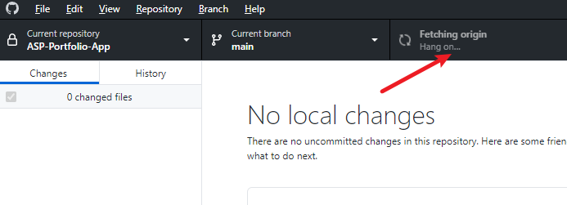

1. Open Visual Studio Code and open folder, Portfolio App.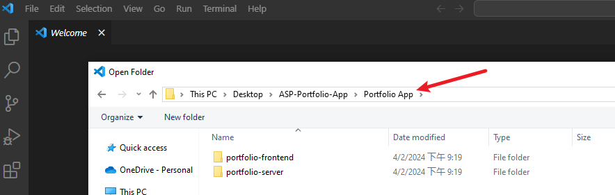
2. Open New Terminal.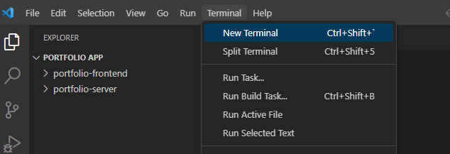
3. Enter cd .\portfolio-server\ and then Enter npm install, and then Enter npm start. You should see the below, Connected to Database(Text in the group if you met any problems)

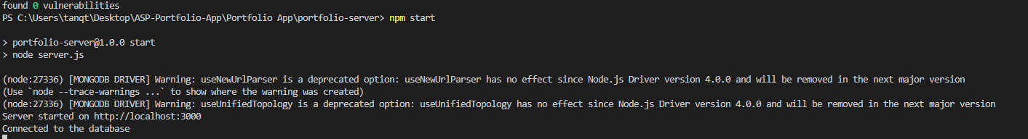

1. Click on the + sign to add a new terminal

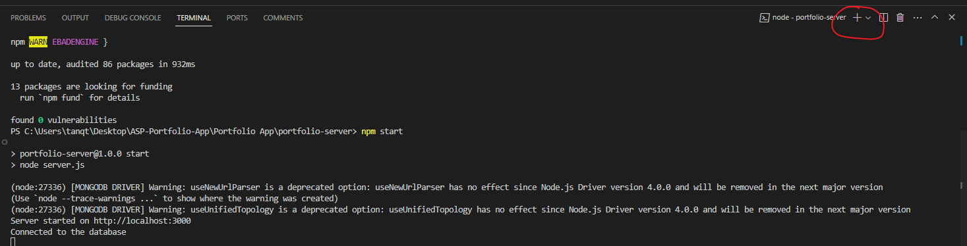

1. Enter cd .\portfolio-frontend\ and then Enter npm install, and then Enter npm start.
2. You should see this

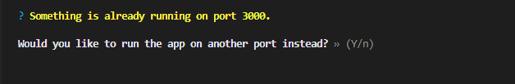

Enter Y to continue.

1. Your default browser should open automatically, and you should see this

